**Lab Assignment-3**

Name: Khushi Prasad

SubGroup: 3CO20

Roll No.: 102183044

Subject: Data Science Fundamentals

Q1. Create two vectors as A = (23, 34 ,56,3 ,0, 0 ) and B=(“c”, “b”, “a”)

CODE:



OUTPUT:

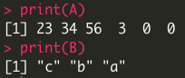

Q2. Generate the sequences as 1:n, m:n and by a difference of 0.6.

CODE:

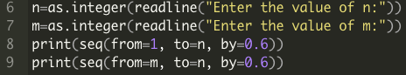

OUTPUT:

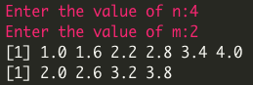

Q3. Divide the range 1 to 50 in 10 equal intervals.

CODE:



OUTPUT:



Q4. Print the pattern 3, 4, 5 five times.

CODE:

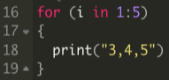

OUTPUT:

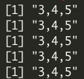

Q5. Generate 8 random numbers.

CODE:



OUTPUT:



Q6. Create a vector as C=(2, 3, 4, 5, 6, 7) and add it to vector A in question 1.

CODE:



OUTPUT:



Q7. Add D= (6, 7) to A.

CODE:



OUTPUT:



Q8. Write a statement to find the square root of each number in C.

CODE:



OUTPUT:



Q9. Find the length of A, B, C above.

CODE:

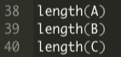

OUTPUT:

